Grade 8 Science
Final Exam Booklet

Name:__________________

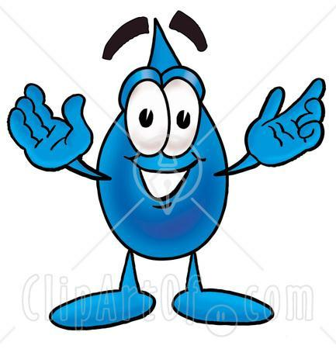
Unit 1: Water Systems on Earth
(Chapters 1,2,3)

Unit 2: Fluids and Viscosity
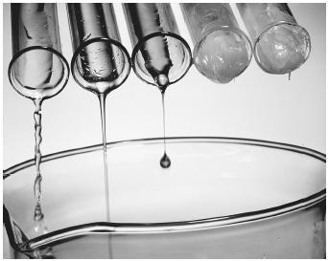
(Chapters 7,8,9)

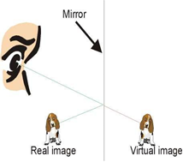

Unit 3:Optics
(Chapters 4,5,6)

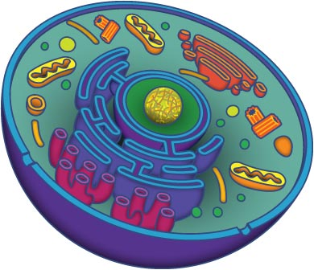
Unit 4: Cells, Tissues, Organs and Systems
(Chapters 10,11,12)

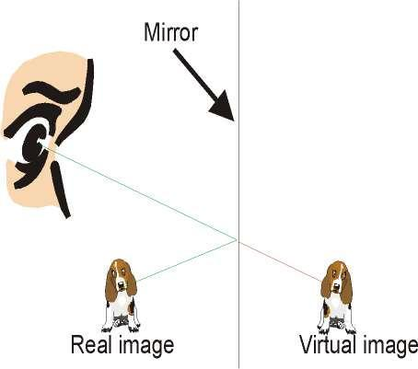

Chapter 1:

How do you use water? | 1.
 | 2.
 | 3.

Water Distribution

% of the Earth’s water is fresh

of this water is frozen in ice sheets.

% of the fresh water on Earth is available.

Why do we not run out of water?_________
Water is constantly being changed from a |  |  |  | to a |  | and back
again.
This is driven by the |  |  | .

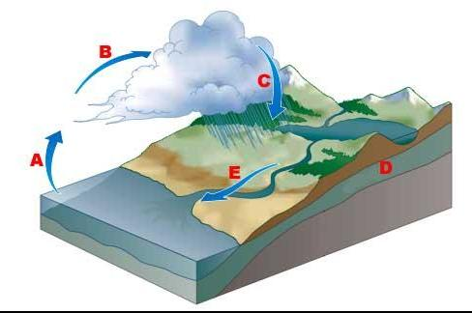
Label the water cycle parts below:
Ocean Water vs. Fresh Water

Differ in three (3) ways.

1. | 2. | 3.
Definition: | Definition: | Definition:

Sources of Fresh Water

1.

2.

3.

4.

5.

Glaciers and Global Warming
In the last 100 years, the average surface temperature has increased by |  |  |  |  | ^{O}C.
The world’s glaciers are melting at a quicker pace than ever before.
What does this mean? | 1.
 | 2.
 | 3.

Drainage Basins
Watershed
The area that drains into a body of water such as a |  |  |  | , pond,
or |  | .
There may be many small within a larger basin.
A divide

For example:

One Component can affect another. For example…

Salinity | Temperature | Convergence of the Labrador
 |  | current and the Gulf Stream
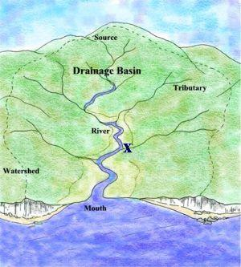

Chapter 2:

Origin of the Ocean
A. Tectonic Plates
Has helped to determine where |  |  |  |  |  |  |  |  |  |  | are located.
They move to change the position of the |  |  |  |  |  |  |  |  |  |  | .
B. Volcanic Action
Has built ocean floor along |  |  |  |  |  |  |  | in areas where plates separate.
Has helped build |  |  |  |  |  |  | in areas where plates have collided and
mountain building occurs.
Water trapped in volcanic materials were released as |  |  |  |  |  |  |  |  |  |  | . It cooled,
condensed and fell back to the earth. This water collected in the lowest parts of the
Earth’s surface… the |  |  |  |  |  |  |  | .
C. Erosion
Aided in the development of |  |  |  |  |  |  |  |  |  |  |  | as material is
removed and deposited into the ocean basins.

D. Glaciation
A force of |  | .
Move materials towards the oceans.

Researching the Ocean Floor…
Technologies Include:
1. ______________________

2. ______________________

3. ______________________
Getting to Know the Ocean Floor
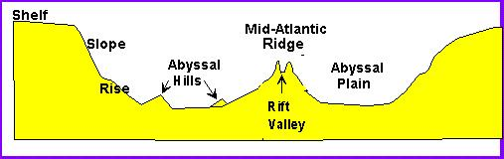

Ocean Currents

Two Local Currents are the Labrador Current ( |  |  |  | ) and the Gulf Stream
( | ).

Tides:

Connected to the motion of the |  |  |  | and the spinning of the Earth.
The |  | exerts a greater force of pull than the |  |  |  | due to its
closer proximity to the Earth.
Two types of tides…
Spring Tides | Neap Tides

Occurs when…

Diagram…

Causes…

Tidal Range:
Shaping our Shoreline

Have the power to erode and deposit sediments.
Factors that affect the interaction of waves and tides on the shoreline are:

1.

2.

3.

4.

Shoreline Features:

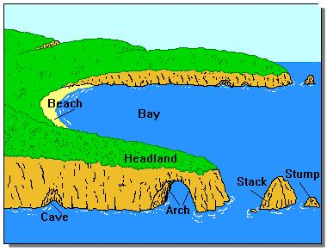

Chapter 3:

Heat Capacity
 | A measure of how long it takes a material to |  |  |  |  | or
 | An example of a material with a high heat capacity is |  |  |  |  |  |  | .
 |  | can store large amounts of heat. |  |  |  |  |  | will
 | transfer this heat to other parts of the world.

Heat transfer resulting from circulation is
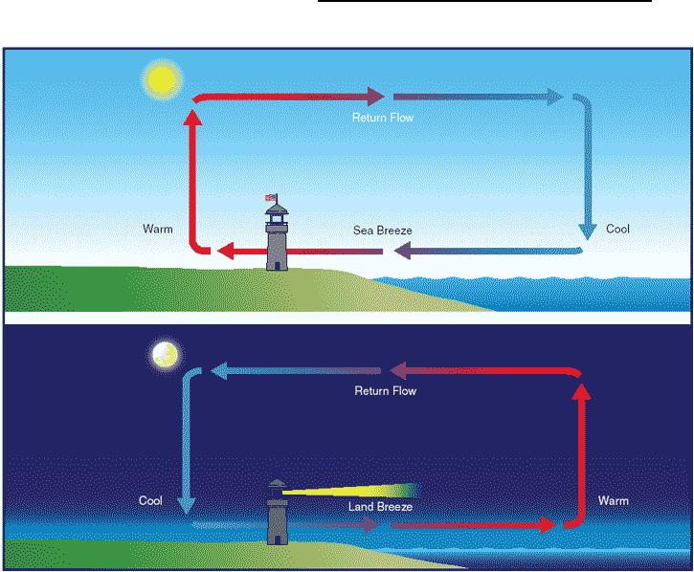

 | Oceans and Climate
 | Refers to the main characteristics of an area’s weather is |  |  |  |  |  |  |  |  |  |  |  |  |  |  |  |  |  |  |  |  |  |  |  |  | .
 | Ocean temperatures can have an effect on the climates of
 | communities.
Due to its high heat capacity:
1.
2.
 | This will cause summers to be |  |  |  |  |  |  |  |  |  |  |  |  |  | and winters to be
El Niño | La Niña

Ocean Currents and Weather
 | Our weather patterns are rapidly changing due to the interactions of the
 |  |  |  | and the |  |  |  |  |  |  |  |  |  |  |  |  |  |  |  |  |  |  |  |  | .
 | Warm surface currents |  |  |  |  |  |  |  |  |  |  |  |  |  | tropical heat to the atmosphere.
 | Colder currents |  |  |  |  |  |  | heat from the atmosphere.
 | When the warm, moist air above the Gulf Stream blows over the colder water of the
 | Labrador Current, it cools and |  |  |  |  |  |  |  |  |  |  |  |  | , producing |  |  |  |  |  |  |  |  |  |  |  | .

Why do temperatures fluctuate rapidly in NL?

Abiotic Factors that affect plant and animal distribution (we tested on books for boats):
1.

2.

3.

4.

5.

6.

Technologies that have contributed to overfishing include:
1.

2.

Offshore Oil Industry

Affects on the marine environment include:
1.

2.

3.

Aquaculture

Definition:

Usually built in sheltered areas such as a .
Problem?

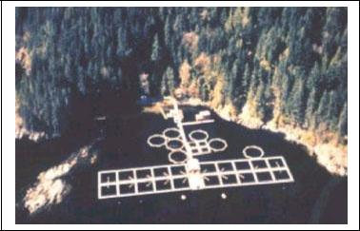

Unit 2: Fluids and Viscosity

Chapter 7:

The Particle Theory of Matter (PTM)….

The 5 main points that make up this theory are:
1.

2.

3.

4.

5.

The 3 states of matter…

Label the states of matter in the following picture.
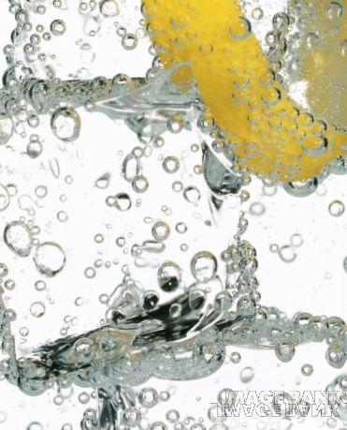
Complete the following table.

State | Shape | Volume | Particle | Particle
 |  |  | Arrangement | Movement

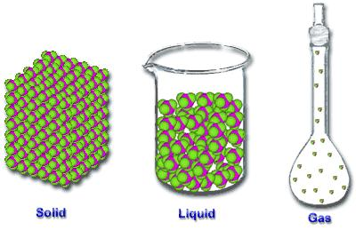

Fluids…
 | Any form of matter that |  |  |  | .
 | The states of matter that can be fluids are: |  |  |  |  | and | .
 | Examples include:
Viscosity…
A measure of a liquid’s |  |  |  |  |  |  |  | to flow.
The |  |  |  | or |  |  |  |  | of a fluid.
A fluid that is viscous is the one that is |  |  |  |  |  |  |  |  |  | .
A force that resists movement is |  |  |  |  |  |  |  |  | .
The greater the friction, the |  |  |  |  |  |  |  | the viscosity.
In a fluid that has high viscosity, the particles are
to each other.

Number the fluids below with 1 being the least viscous and 4 being the most viscous.
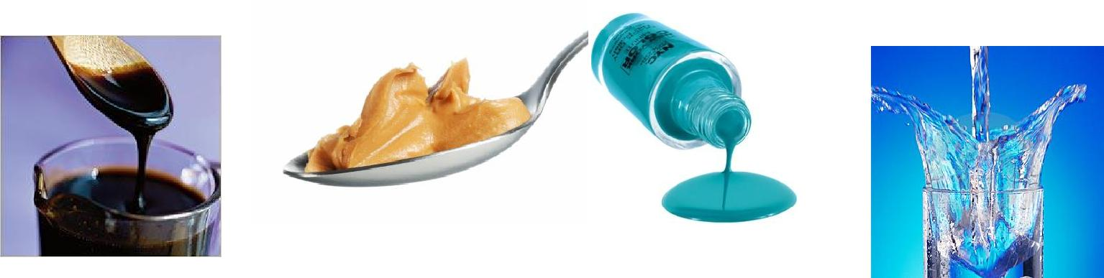

Flow Rate…
The speed at which a fluid flows from

corn syrup | dishwashing | water
 | liquid

Factors that Affect Viscosity…

1. Temperature |  | 2. Concentration
Temperature = | Viscosity | The amount of a substance dissolved in a
 |  | specific volume.
 |  | Concentration = | Viscosity

** The _____________ is true for gases.

3. Attractive Forces
Attractive Forces = | Viscosity
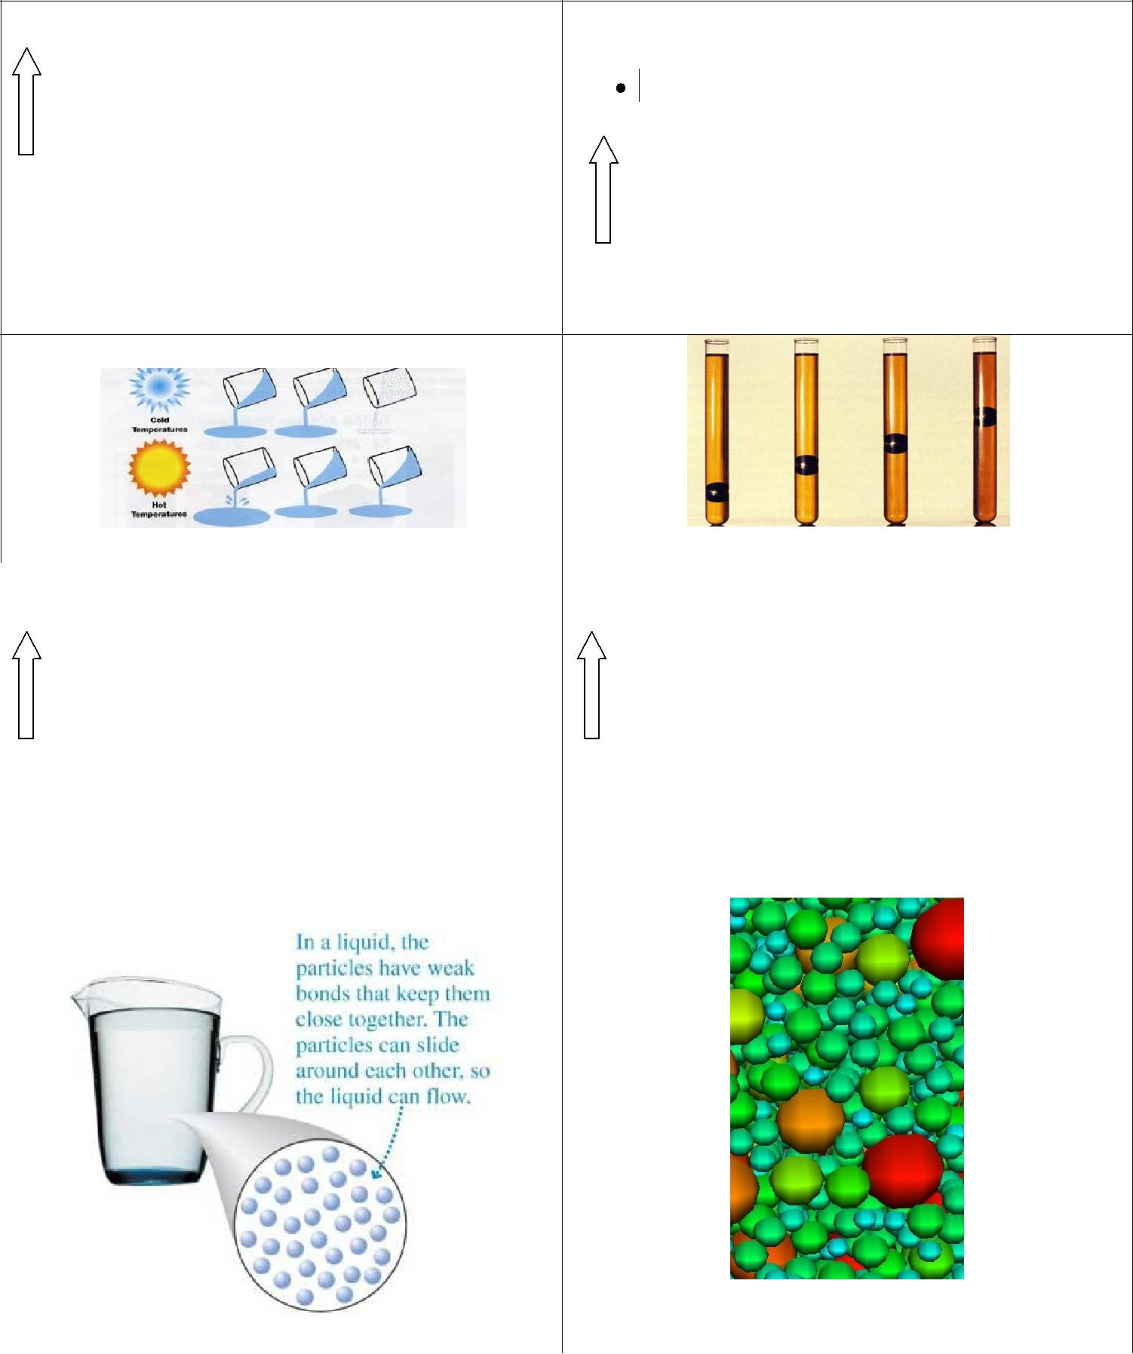

Chapter 8:

Density:
A measure of the |  |  |  | contained in a given |  |  |  |  |  |  |  | .
A substance with a lower density will |  |  |  |  |  |  |  |  |  | on substances with higher
densities.
The PTM states:
Different substances have different sized |  |  |  |  |  |  |  |  |  | .
There are |  |  |  |  |  | between the particles.
The greater the spaces, the |  |  |  |  |  |  |  | particles therefore the
the density.
For example

In general, gases are |  | dense than liquids and liquids are
dense than solids.
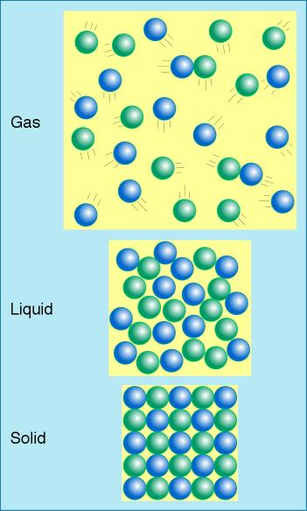
3

Calculating Density:
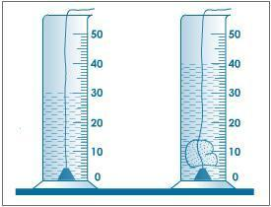
You must know the following to determine the density of a substance…
The amount of matter in a substance or
The amount of space occupied by the substance or

- To measure the volume of an irregular shape, you
will need to determine the amount of water it

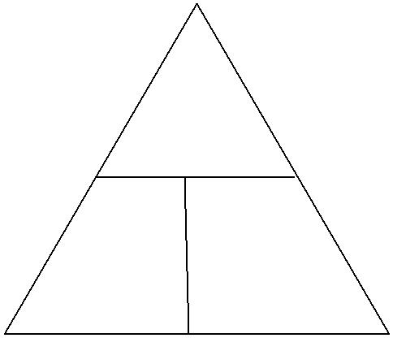
Formula for calculating density:

Density (D)=

Sample Problems:

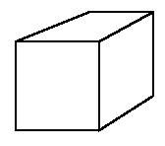
- Find the density of a 10g mass of a substance that has a volume of 2.0 cm³.

- You want to put 10g of salt into a container. What is the volume of the container if the salt completely fills it?
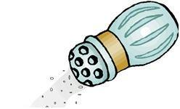

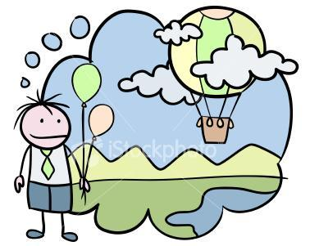

- What is the mass of 1500mL of helium?

Complete the practice problems on pages 312-4

Temperature and Density
Increasing temperature will cause the particles in a substance to

energy, |  |  | and take up |  |  | space.
o Results in |  |  |  | density.

Applications of Density…

1.

2.

3.

4.

5.

6.

7.

Chapter 9:

Force:
Anything that causes a change in the |  |  |  |  |  | of an object.
A |  | or |  |  | .

There are two kinds of forces:

Balanced Forces | Unbalanced Forces

Mass vs. Weight:

Mass | Weight

Measured in | Measured in
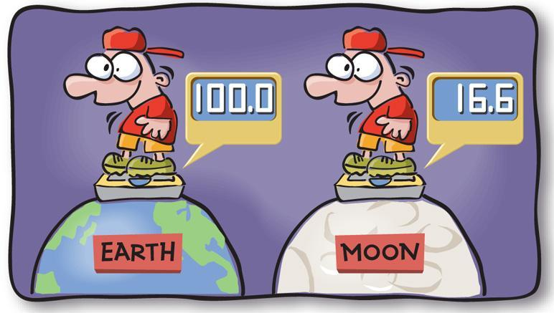

Buoyancy:
The force of an object submerged in or floating on fluids.

The amount of buoyant force that would push up against the object immersed in the fluid equals

If the density of the immersed object is greater than the density of the fluid, it will

Which will float (circle one)? Why?

- Wooden boat vs. water logged stick

- Metal block vs. metal boat

- A sealed empty water bottle vs. full water bottle

Average Density:
The total mass of all substances that make up an object divided by the

o Technologies Developed

1.
2.

3.

Pressure:
The force acting on a certain area of |  |  | .
The larger the force,
The smaller the area,

Calculating Pressure:
The unit for pressure is the |  |  | (symbol)
You can determine pressure if you know |  |  |  |  | and
o Formula
Pressure (P) =
Sample Problems…

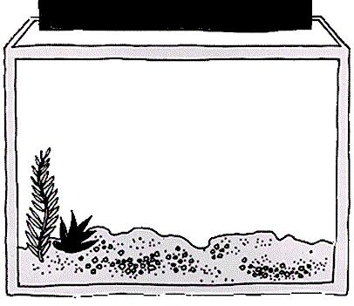
- An aquarium is filled with water that weighs 10 000 N. If the base of the aquarium has an area of 1.6 m², what pressure does the water exert on its base?

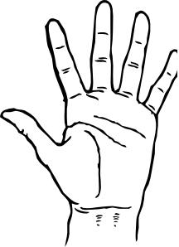
- If the atmospheric pressure is 101 200 Pa and you are holding your hand, the atmospheric pressure is exerting a force on your hand. If the area of your palm is 0.006 m², calculate the force on your hand.

- The weight of water in a glass is 4.9 N. If the water is exerting a pressure of 1700 Pa on the bottom of the glass, what is the area of the bottom of the glass?
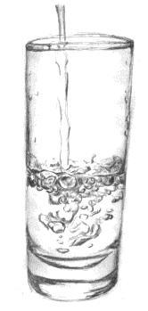

Complete the practice problems on pages 351-3

Determine Why?

- A person wearing snowshoes can walk across a section of deep snow without sinking.

- The nozzle of a garden hose can be used to create faster or slower flow of water.

Atmospheric Pressure:
The pressure exerted by |  |  |  | surrounding the Earth
that is held by the Earth’s |  |  | .

Pascal’s Law:
Pressure applied to an enclosed fluid is transmitted with |  |  |  |  | force
throughout the entire container.
Basis for |  | and
- Hydraulics: the study of pressure in

  - Systems will transmit applied force through a liquid to move something else.
  - The pressure produced will exert in all directions

  - Use liquids because they are

  - The liquid must be enclosed in a tube or pipe.

  - This pressure causes motion at the
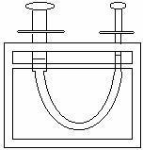
o Pneumatic Systems:
▪ Uses in an enclosed space.
- Gases can be

Pressure and Volume:
Increasing the pressure of a fluid will __________volume by the same amount

Temperature and Volume:
Increasing temperature will the volume of a fluid

Temperature and Pressure:
Increasing temperature of a fluid will the pressure.

o Why do we use the following symbols on aerosol cans?

Unit 3: Optics
Chapter 4:

The History of Light
Pythagoras
A |  | philosopher

He believed that beams of light were made of
The eyes detected these particles and allowed us to

Albert Michelson
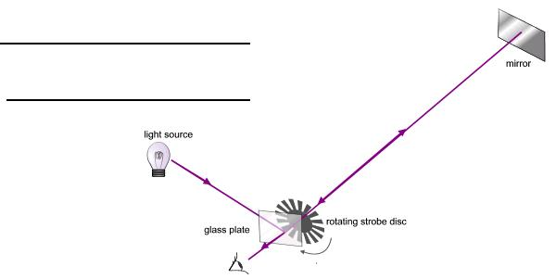
First person to measure the

o He calculated it to be m/s

Speed: Light vs. Sound
Light =
Sound =

1. Explain why you see the lightning before you hear it.

3

2. Is it possible for stars to be burned out even though we are seeing them in our night sky? Explain.

Light Technologies include:
1.
2.
3.
4. |  | 8.
5. |  | 9.
6. |  | 10.
7.
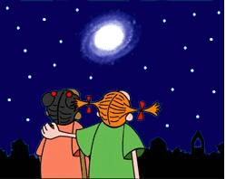

Light
A form of that can be detected by the
Visible light is a mixture of all of the colors of the

Properties of Light
1. |  | 2.
3. |  | 4.
5. |  | 6.

4

Visible Light Spectrum
Can be seen due to the through a prism.
List the constituent colors of white light by the picture below

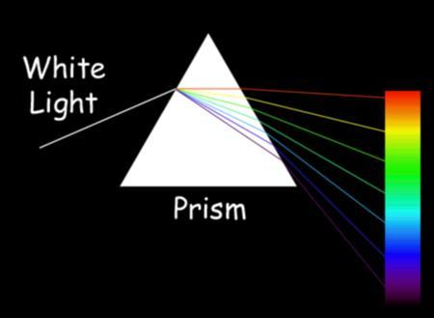

Has the smallest refraction and has the greatest.
When a laser is shone through a prism, the light will refract but NOT disperse. Why?

The Wave Model of Light
Explains that light is a type of |  | that travels through empty space and
transfers energy from one place to another.
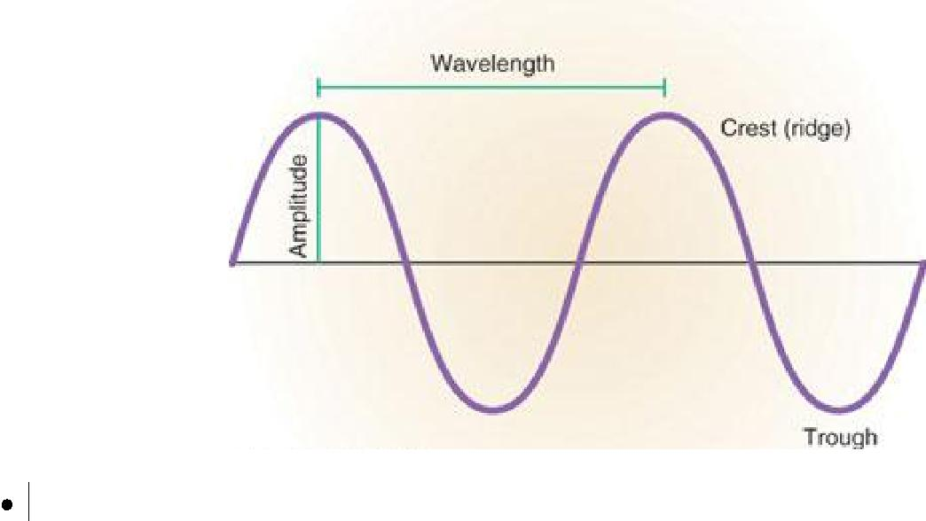

Frequency is the number of seconds.

o It is measured in

that pass a point in

( )

Longer |  |  |  | refract the
High frequency waves have |  |  |  |  |  | wavelengths.
Low frequency waves have |  |  |  |  |  | wavelengths.
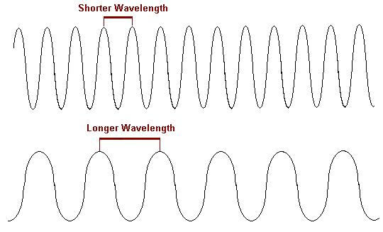

Electromagnetic Radiation

The transmission of energy in the form of waves that extend from the longest to the shortest .
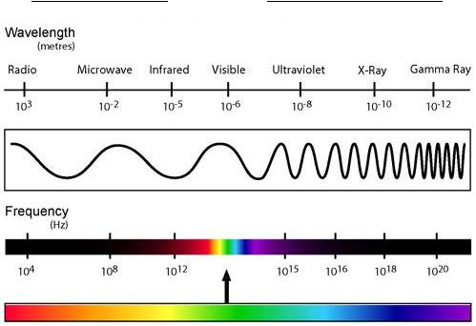

 | Type of Electromagnetic | Interesting Facts | Examples of Uses
 | Radiation
1. Radio Waves
2. Microwaves
3. | Infrared Waves
4. | Visible Light Spectrum
- Ultraviolet (UV) Waves

- X-Rays

- Gamma Rays
Generally |  |  |  |  | energy radiation is more harmful to
humans.
The Earth’s |  |  |  |  | is able to protect us from some of the more
dangerous radiation present in space.
Positive and Negative Effects to Exposure to Electromagnetic Radiation
 |  |  | X-rays |  | Ultraviolet | Radio Waves
Positive Effects
Negative Effects

Chapter 5:

The Ray Model of Light
Used to study the behavior of light when it meets a
Light is represented by a |  |  | or |  | that shows
the direction the light is travelling.
Different materials allow light to travel through it in varying degrees.

1. 2.

3.

**Remember light travels in a straight line. This is called

Reflection
The incoming light ray is called the
The reflected ray is called the
An imaginary line that is perpendicular to the barrier is called the
The angle formed by the incident ray and the normal is the
The angle formed by the reflected ray and the normal is the

Label the above on the diagram below.
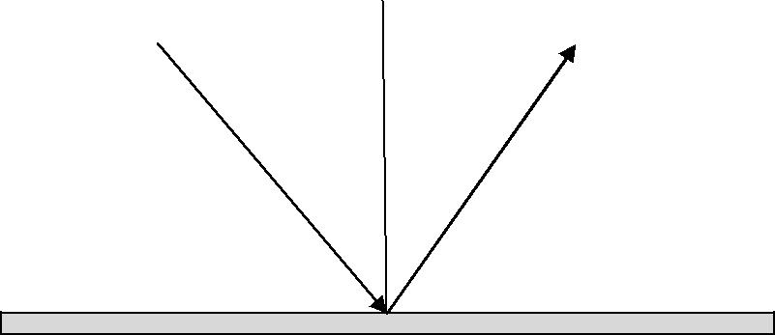

Specular vs. Diffuse Reflection
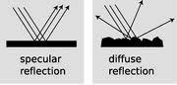

Applications of specular and diffuse reflection include:

1.

2.

3.

Law of Reflection
Sates that the angle of |  |  |  | equals the angle of
Types of Mirrors
 |  |  | Characteristics of Image |  |  | Examples
1. Plane Mirror
 |  | 1. | S
 |  | 2. | P
 |  | 3. O
 |  | 4. T
2. Concave Mirror
 |  | 1. | S
 |  | 2. | P
 |  | 3. O
 |  | 4. T
 |  | 1. | S
 |  | 2. | P
 |  | 3. O
 |  | 4. T
 |  | 1. | S
 |  | 2. | P
 |  | 3. O
 |  | 4. T
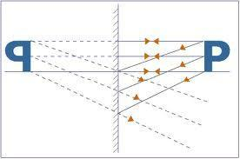
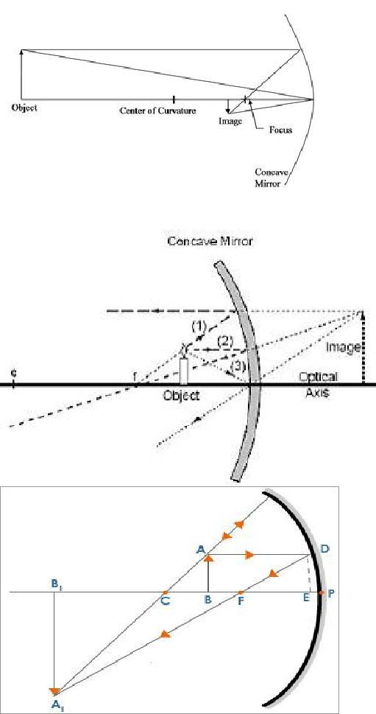

5

3. Convex Mirror | 1. | S
 | 2. | P
 | 3. O
 | 4. T
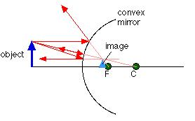

Ray Diagrams… parts to know
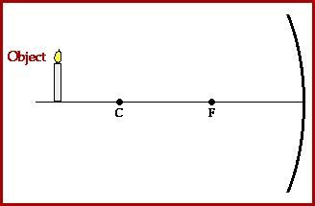

Real vs. Virtual Images

Real Image | Virtual Image

Formed?

Located?

Refraction
 | The |  |  |  | of a wave when it travels from one |  | to another.
 | The |  |  |  | ray is found in the second medium travelling in a different
 |  |  |  | than the incident ray.
The angle between the normal and the refracted ray is called the

6

Label the diagram below…
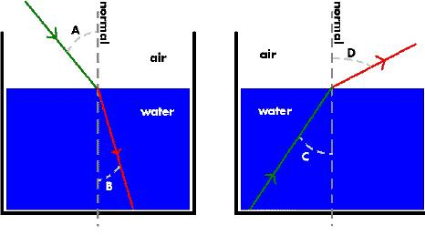

1. What happens…

- as light travels from a less dense medium to a more dense medium?

- as light travels from a more dense medium to a less dense medium?

2. Why is the object not where you think it is?
Chapter 6:

Lenses
 | A |  |  |  | piece of transparent material that |  |  |  |  |  |  | light in a
 | predictable way.
 | Usually made from |  |  |  |  |  | or
 | There are two types of lenses:
 |  |  |  |  | Diagram |  |  |  | Affect on Light
 |  |  |  |  |  |  |  |  | Rays?
 |  | 1. Convex
 |  | Lens
 |  | 2. Concave
 |  | Lens

Corrective Lenses:

Definition/ What is happening? | Lens used to correct?

Nearsightedness

Farsightedness
Unit 4: Cells, Tissues, Organs and
Systems

Chapter 10 – The cell is the basic unit of life.
Compare past and present ideas of what living things are made of.

 | Early Idea | Current Theory
What is a cell?

What are FOUR characteristics of living things?

Define:
Growth:

Movement:

Stimulus:

Reproduction:

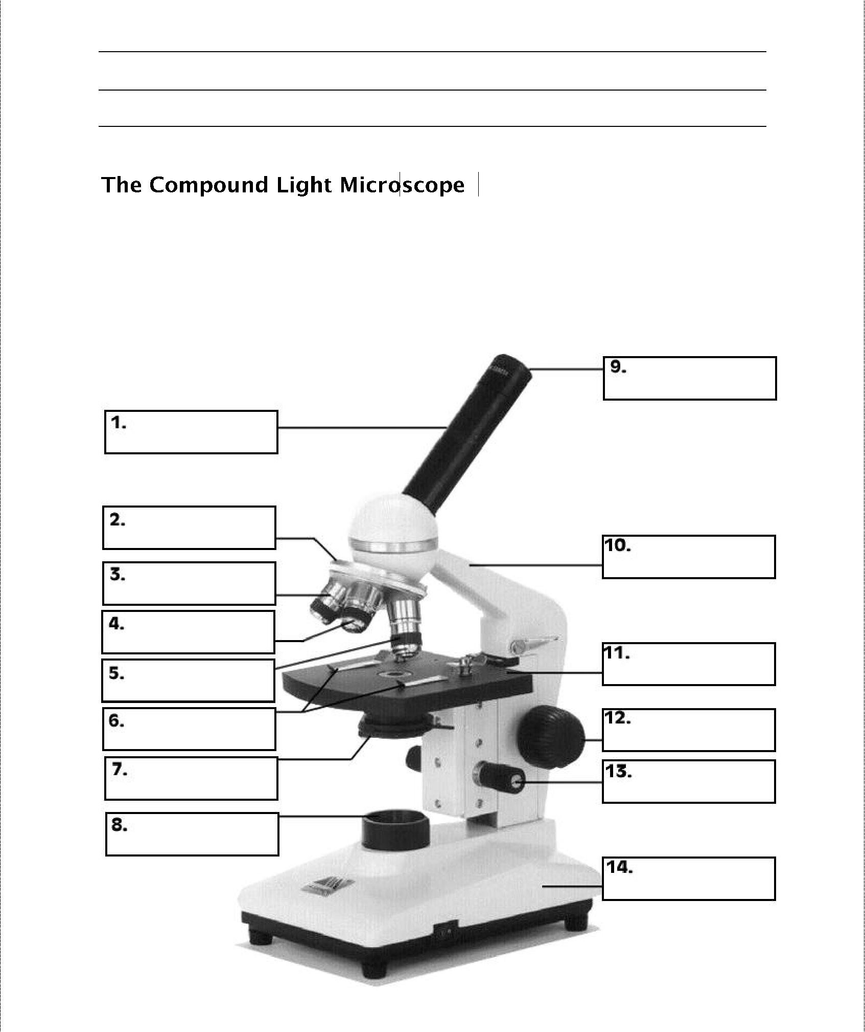
Give an example of stimulus – response reaction.

Label the parts of the microscope below.

3

Identify the function of the microscope parts in the following table.
PART | FUNCTION
Eyepiece
Body tube (barrel)

Coarse adjustment knob
Fine adjustment knob
Objective lenses
Revolving nosepiece
Stage
Iris diaphragm
Light source
Base
Arm

How would you calculate the Total Magnification of a microscope?

What is the total magnification of an object when using the low power lens (4X) in a microscope with an eyepiece magnification of 10X?

Cells and Cell Theory
List the three main points of the cell theory.

What is an organelle?

Outline the structure and function of the organelles listed below.
Cell Organelle |  | Structure and Function
Cell Membrane

Cytoplasm

Cell Wall

Nucleus

Vacuole

Chloroplast

Mitochondrion

5

Indicate whether the following organelles are present in a plant cell an animal cell or both.
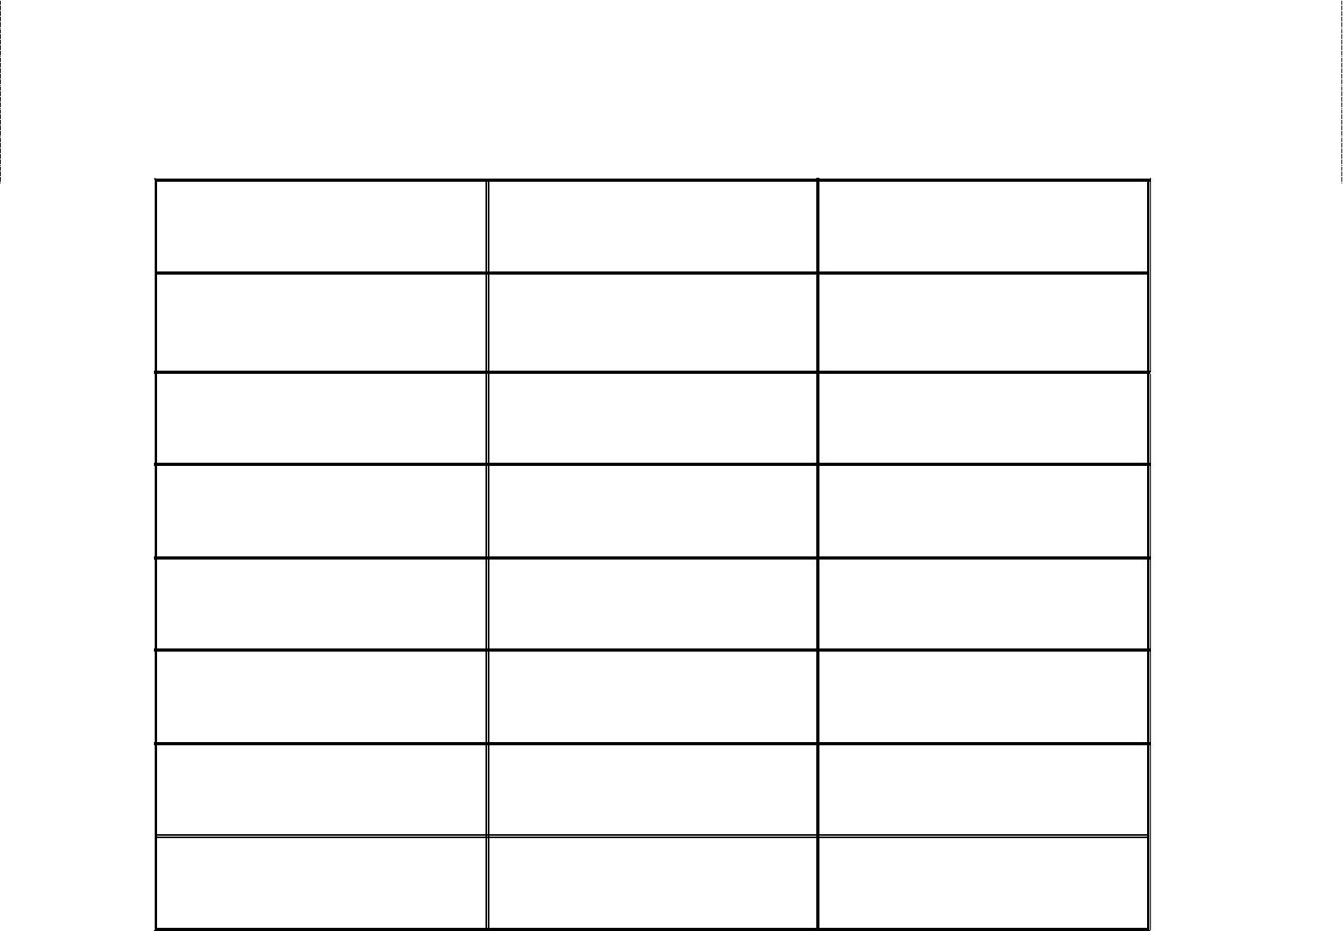

Organelle | PLANT | ANIMAL

Cell membrane

Cytoplasm

Cell wall

Nucleus

Vacuole

Mitochondrion

Chloroplast

Explain why cells divide.

How do body cells divide? What other types of organisms divide in this manner?

6

- Label the following cell parts. Identify the cell type (plant or animal).
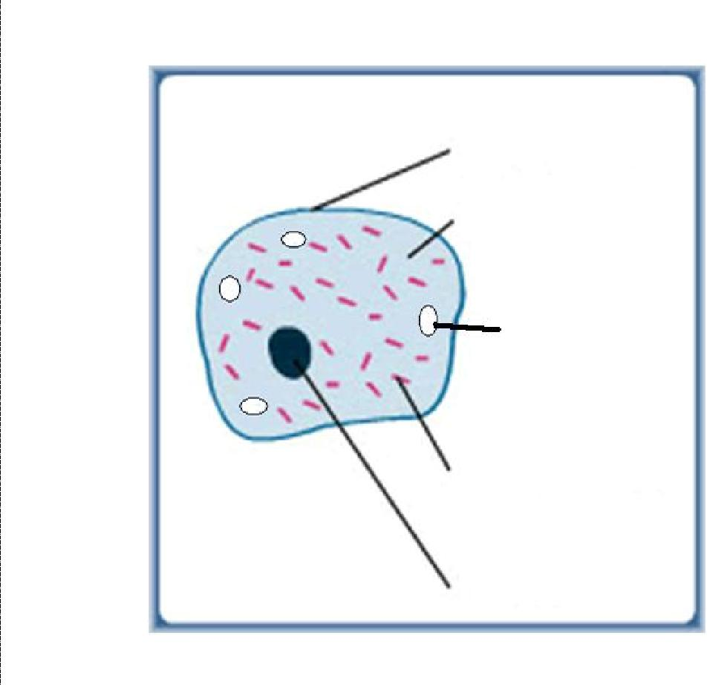

Cell Type: _______________________________
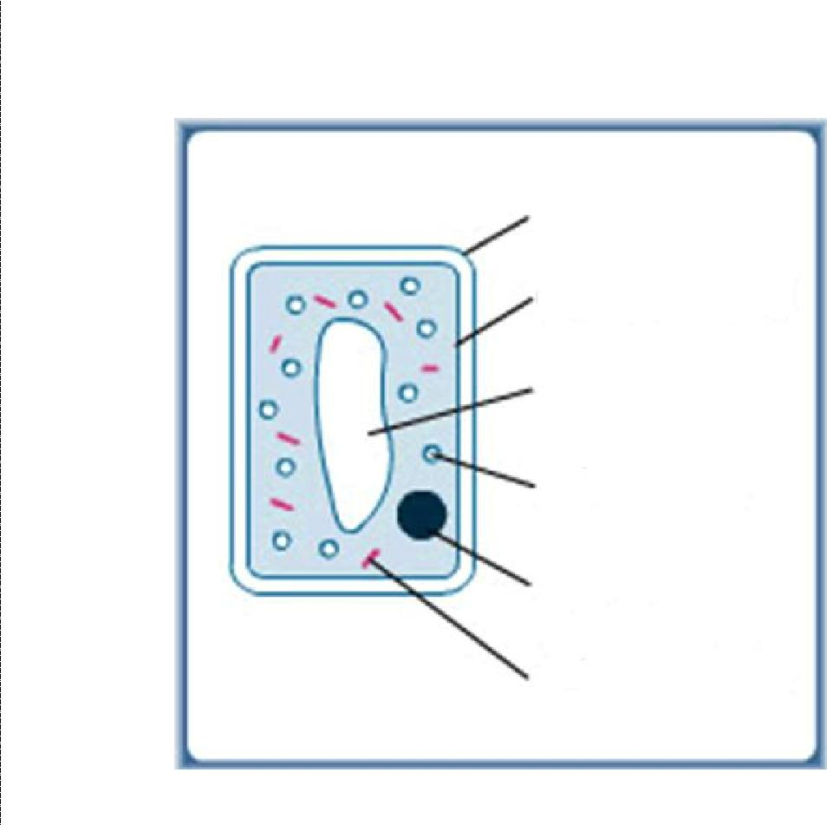

Cell Type: _______________________________

Chapter11:______________________________________________________________________________________________________________________________________

What are the three main characteristics of systems?

Complete the flowchart that illustrates the levels of organization from a cellular level on up to the organism.
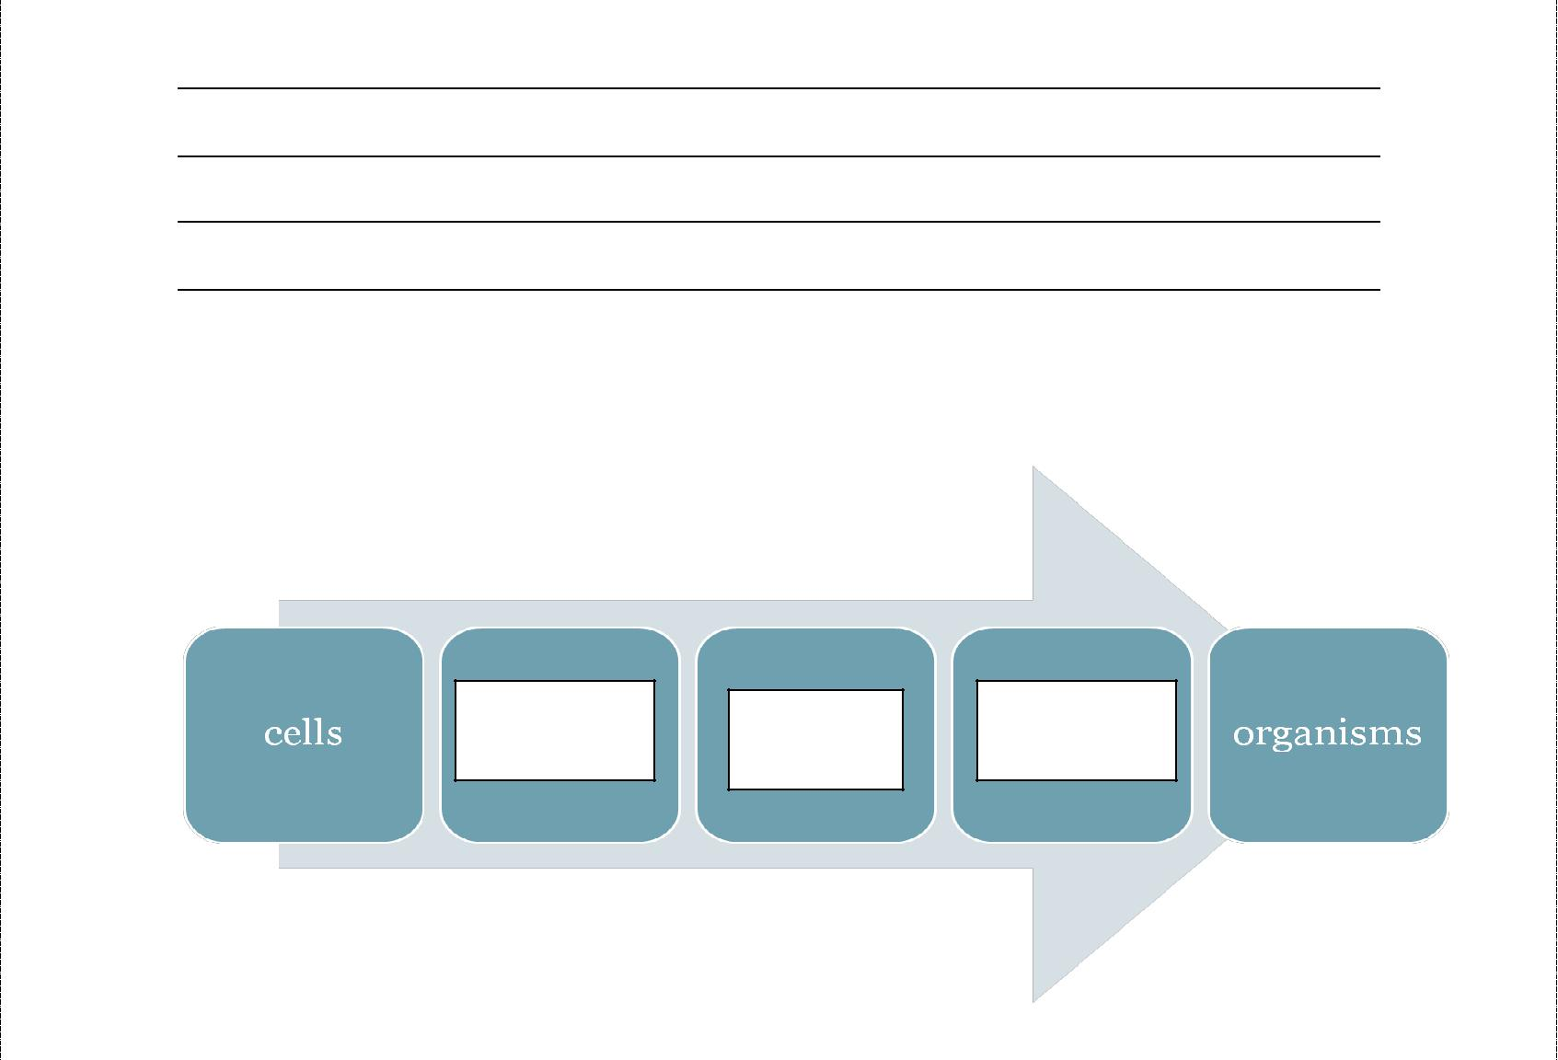

Compare Tissues and Organs in terms of their composition. Give four examples of each.
Tissues | Organs

Examples: Examples:

Organ Systems p.428-430 What is an organ system?

Identify the main organs and tissues as well as the function of each.

Organ System | Main Organs and | Main Functions
 | Tissues

Digestive System

Circulatory System

Nervous System

10

Organ System | Main Organs and | Main Functions
 | Tissues

Respiratory System

Excretory System

Muscular System

Chapter 12 – The health of the body depends on the health of its interdependent systems. p.434

- Cells and the organisms that they make up have the same basic needs. These include:

- Briefly outline how the systems below depend on one another.
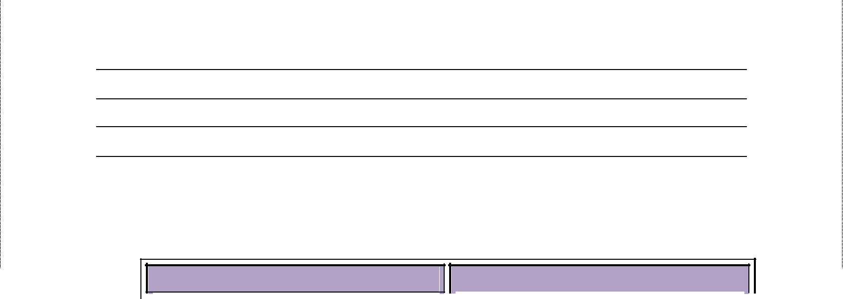

Systems | Connection
Circulatory and
Respiratory

Circulatory and Digestive

Nervous and Muscular

- Identify three factors that affect the health of body systems.

- Compare and contrast lifestyle and genetic factors that affect our body systems.

- Briefly describe the technologies below that have been designed to assist damaged organs and/or systems.
Artificial Heart

Insulin Pump

- List six examples of careers that are associated with the health of body systems.

7. Identify the effects of lifestyle factors on our health.

Lifestyle Factors | Effects
Diet high in fats and cholesterol

Being overweight

Smoking

Drugs and alcohol

Lack of exercise

