9 Science Chemistry Scientific Literacy

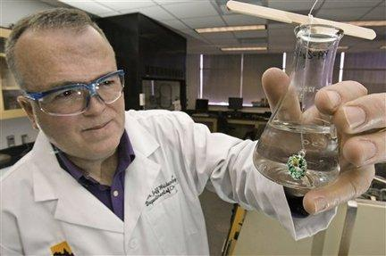
Toxic Jewelry

Name: ______________________________

______/20 = %

Case Study
A 60-year-old man complains of low back pain, which is causing progressive difficulty in walking. The pain has gradually increased and his discomfort is especially noticeable after prolonged sitting. The patient has been making jewelry for about 35 years.
Diagnosis: cadmium poisoning.

Cadmium
• Cadmium is odorless.
• Cadmium is resistant to corrosion.
• Cadmium metal and its oxides are insoluble in water.
• Solid cadmium is inflammable but powdered cadmium will burn and release corrosive and toxic fumes
- The melting point of cadmium is 321۫ C.
Questions (6 marks)
- What is the symbol for cadmium? ___________________
- What is cadmiums atomic number? __________________
- How many electrons does cadmium have? ____________
- Is cadmium a metal or a non -metal? _________________
- Would cadmium conduct heat and electricity? ______________ Explain. ___________________________________________________________________________

Survey (2 marks)
- Do you wear jewelry? If yes, what type of jewelry do you wear? __________________
- Have you ever bought jewelry from Ardenes or Aldo, either for yourself or for someone else? ____________________

Marketplace: Toxic Jewelry
Canadians who buy low-cost jewelry from popular fashion chains may be wearing products made with cadmium, a heavy metal that can be particularly toxic for kids.
A CBC Marketplace investigation reveals some Ardene and Aldo Accessories jewelry manufactured in China contains thousands of times more cadmium than Health Canada says is safe for children.
Health Canada considers cadmium to pose a threat similar to lead if ingested.
Cadmium is a known carcinogen, which can lead to kidney failure, bone loss and other complications in those who are chronically exposed over time.
There are no known risks for people who wear contaminated jewelry. Rather, swallowing or chewing on a piece of jewelry containing high concentrations of the toxic metal could allow it to seep into the body.
"Any major system in your body can be harmed by cadmium," says James Van Loon, director of risk management at Health Canada's consumer product safety branch.
Children's bodies more readily absorb the toxic metal and, since they are more likely to put things in their mouths, Van Loon says jewelry that is marketed to those under 15 should contain virtually no cadmium.
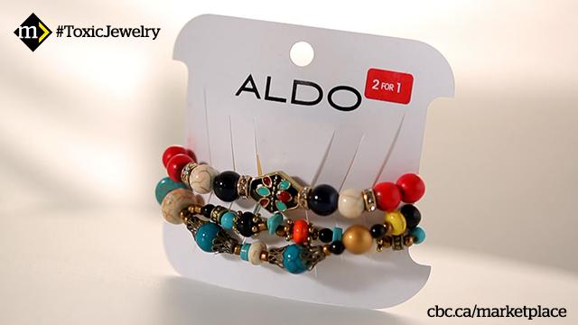
Marketplace sent a group of 12-year-old girls to choose jewelry pieces that appealed to them, since cadmium is considered especially unsafe for children. Marketplace also selected other pieces to test.
In total, Marketplace tested more than 50 pieces of costume jewelry, including necklaces, earrings and bracelets, from various retailers.
Researchers from University of Toronto and École Polytechnique de Montréal tested the jewelry and found seven items from Ardene and Aldo Accessories contained between 15 and 7,000 times the Health Canada threshold for cadmium in children's jewelry.
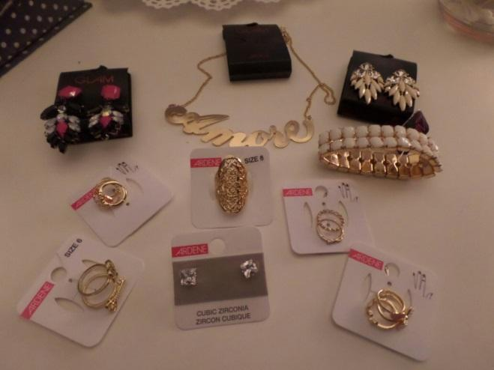
A shiny blue metal pendant on one Ardene necklace was nearly 100 per cent cadmium. The products Marketplace tested did not list the materials used in the jewelry.
"The results were astonishing," says Dr. Gérald Zagury, who performed the tests and has published several studies on heavy metals in jewelry. He says it was the highest cadmium amount ever reported in Canada for such a product."It's pretty close to pure cadmium," he says.
The six other items also contained high concentrations of the heavy metal.
At 79 per cent cadmium, a decorative charm on a beaded Aldo bracelet contained more than 6,000 times the Health Canada threshold for children's jewelry.
Zagury tested the charm to see what would happen if a small child swallowed it. The results showed that a child's body would absorb unsafe amounts of the metal.
Zagury says chewing on contaminated jewelry could also pose a health risk for kids.
"I would not allow my daughter, for example, to put such a sample in her mouth, even if it's not swallowed," he says. Zagury's daughter is 7.
Aldo and Ardene declined to speak with Marketplace on camera about the results. In an email, an Aldo spokesperson said it would remove the items Marketplace identified from store shelves.
"We are committed to increasing our monitoring efforts, and we will work with our vendors to enforce compliance with our internal guidelines," a spokesperson wrote.
Ardene agreed to further investigate the four products identified by Marketplace, though the company says the jewelry wasn't meant for children. The company also stated that it hasn't received "any customer reports of incidents related to cadmium."
Marketplace also shared the test results with Health Canada.
In response, Van Loon says Health Canada sent inspectors to speak with Ardene and Aldo about the products Marketplace identified in order to "figure out to what extent these may actually be marketed straight to kids." Van Loon says it's up to parents to make sure kids don't have access to jewelry intended for adults.
Though Canada's policy on cadmium in kids' jewelry remains a guideline, Health Canada can compel companies to stop selling a product if it poses a risk to human health. In the past, Health Canada has recalled children's jewelry products containing high amounts of cadmium.
Ardene has been the subject of five voluntary Health Canada recalls since 2007 for selling products containing high concentrations of cadmium or lead.
Watch the Marketplace documentary: Toxic Jewelry

Questions
- Is this a gender issue? Explain. (2 marks)

- Since it has to be ingested should people be concerned about cadmium poisoning from jewelry? Why or why not? (2 marks)

- (a) Would you eat fish that had been exposed to cadmium? Why or why not? (2 marks)

(b) Why is this different than wearing jewelry that has high levels of cadmium in it? (1 mark)

- What is another element that is toxic and found in jewelry? (1 mark)

- Even though it is toxic why do you think companies use cadmium in its jewelry? (2 marks)

6. Should jewelry companies be made to include the ingredients found in their costume jewelry? Justify your answer. (2 marks)

